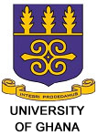

INVITATION TO WORKSHOP
ON ORGANIC SOLARCELLS
The Organic electronics group of the Department of Chemistry, University of Ghana, Legon, Accra, Ghana, in collaboration with Department of Pure and Applied Chemistry, University of Strathclyde, Glasgow, UK, invites you to its maiden workshop on Organic Solar Cells.
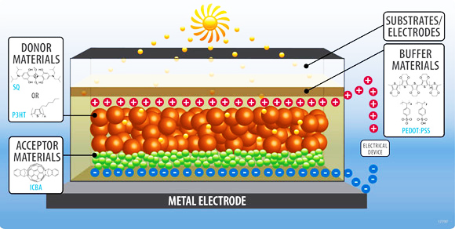
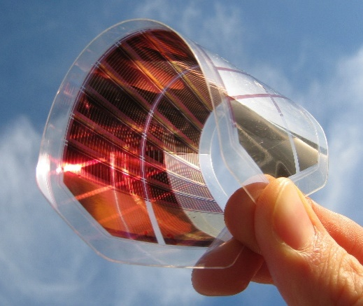

Theme: Organic Solar Cells and Related Technologies (for the renewables era).
Date: Thursday 30th Friday to 31st July, 2015.
Venue: Lower lecture theatre, Department of Chemistry, University of Ghana, Legon, Accra.
Time: 10:30am
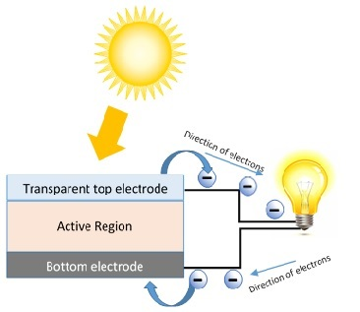
Speakers
- Prof Peter Skabara, University of Strathclyde.
- Dr Neil Findlay, University of Strathclyde.
- Miss Jessica Skabara, University of Strathclyde.
- Dr Neil Robertson, University of Edinburgh.
- Prof Geoff Williams, University of Durham.
- Boniface Yeboah Antwi, University of Ghana.
Hosts
- Prof Robert Kingsford-Adaboh, University of Ghana.
- Dr Richard Boakye Owoare, University of Ghana.

