ABSTRACT
As Ghana’s population ages, the responsibility for caring for older adults increasingly falls on unpaid family caregivers in the absence of a formal long-term care system. This thesis examines the labour market outcomes, well-being, long-term care financing preferences, and willingness to pay for care services among unorganized caregivers of older adults in Ghana.
Using Ghana’s Care Economy Data, the thesis employs a range of quantitative methods across four interrelated studies. Logistic regression was used to examine the effects of caregiving intensity and burden on labour force participation and work hours. Ordinary Least Squares regression and well-being valuation methods were used to assess the multidimensional effects and monetary value of caregiving-related changes in well-being. Multinomial logistic regression examined caregivers’ preferences for alternative long-term care financing models, while a Tobit model, guided by Contingent Valuation Theory was used to estimate caregivers’ willingness-to-pay (WTP) to outsource least-preferred care tasks.
The results showed that both high-intensity and high-burden caregiving have notable effects on labour force participation and the work hours of unorganised caregivers. High-intensive caregivers were associated with an approximately 14% increase in the probability of reducing work hours. Caregiving was significantly associated with reduced well-being, particularly in the physical and environmental domains while emotional support improved well-being, especially in the social domain, with the greatest benefits among spousal caregivers. Preferences for LTC financing model were shaped by caregivers’ economic status, beliefs in caregiving responsibility, the caregiver-care recipient relationship and specific caregiving tasks. Caregivers providing personal care favoured insurance-based financing, while those offering emotional support leaned toward tax-based models, particularly when caring for a parent or even holding strong beliefs that caregiving is primarily a family or government responsibility, across all income levels. The study also found a measurable willingness to pay to outsourced care, with higher WTP among caregivers with greater education, income, urban residence, and caregiving burden.
Overall, the findings demonstrated that unpaid caregiving for older adults imposed significant labour market, well-being, and economic costs on caregivers and their families. The study highlighted the need for equitable, gender-responsive, and culturally appropriate long-term care policies that recognise and support family caregivers, while developing sustainable financing mechanisms and formal care services to reduce caregiver burden and strengthen Ghana’s long-term care system.
Published PhD articles:
- Caregiving dynamics and labor market outcomes of unorganized caregivers of older adults in Ghana | Journal of Health, Population and Nutrition | Springer Nature Link
- The future of long-term care financing in Ghana: preferences among dual-role unorganised caregivers of older adults | npj Health Systems:
Biography-Daniel Offei
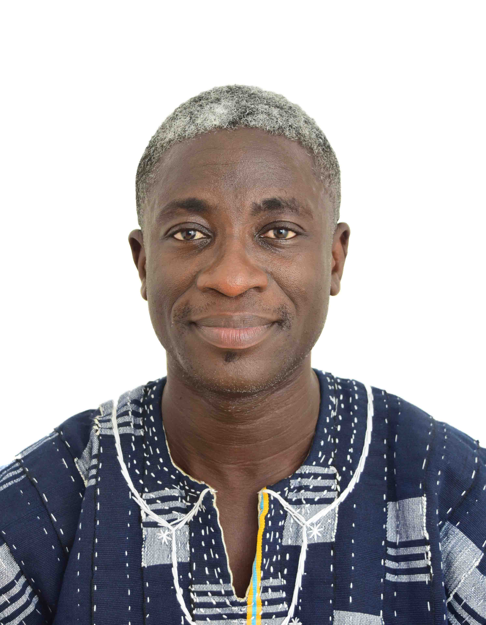

Mr. Daniel Offei holds a Master of Science in Economics from the University of Lausanne, Switzerland, and a Bachelor of Arts in Economics from the University of Ghana.
Professionally, Daniel has served as a Lecturer at Central University. His academic and research interests lie at the intersection of long-term care for older adults and the economic and social implications of caregiving.
Since beginning his PhD at the Institute of Statistical, Social and Economic Research (ISSER), University of Ghana, Daniel has developed strong international academic collaborations and research networks. As a PhD candidate on Ghana’s Care Economy Project, he served as a Guest PhD Researcher at Aarhus University, Denmark. His PhD by publication has also provided opportunities to disseminate his research and engage with scholars internationally, including presentations at the 2025 Transforming Care Conference at the University of Helsinki, Finland; the QAR_Net Care Conference at the University of Sheffield, UK; and the Early Career Research Workshop at WU Vienna University of Economics and Business, Austria.
Daniel is currently a member of the Transforming Care Network (TCN) and the Quantitative Analysis and Research Network for Care (QAR-Net Care). His research is driven by a commitment to contributing to the design of equitable and sustainable long-term care systems for older adults in Ghana.

